Day 393 — Unsupervised ML Revision
Complete Revision Notes | K-Means • Clustering Workflow • Distance Metrics • Elbow & Silhouette • PCA • Dimensionality Reduction
Learning goal: master core unsupervised machine learning and dimensionality reduction: understand centroid-based clustering (K-Means and K-Means++), evaluate distance metrics (Euclidean, Manhattan, Cosine), optimize K using the Elbow method (WCSS/Inertia) and Silhouette Analysis, formulate Principal Component Analysis (PCA) through covariance eigen-decomposition and SVD, interpret Scree plots and cumulative variance, and execute end-to-end customer segmentation pipelines.

1. What is Unsupervised Machine Learning?
Unsupervised Machine Learning is the branch of machine learning where algorithms are trained on unlabeled data: D = {x_i} for i = 1 to n, with no target labels y or ground-truth guidance provided.
Instead of predicting a predetermined target, the algorithm discovers innate underlying patterns, geometric structures, cohesive clusters, or lower-dimensional manifolds directly from the intrinsic feature distributions.
Unsupervised Paradigm | Core Mathematical Goal | Prominent Algorithms | Primary Industrial Use Cases
Clustering | Partition observations into homogeneous groups (clusters) where intra-cluster similarity is maximized and inter-cluster similarity is minimized | K-Means, K-Means++, DBSCAN, Agglomerative Hierarchical Clustering, Mean Shift | Customer segmentation, genomic sequencing grouping, document topic clustering
Dimensionality Reduction | Project high-dimensional data (d features) onto a lower-dimensional subspace (k features, k << d) while preserving maximal variance or geometric distances | PCA, Truncated SVD, t-SNE, UMAP, Factor Analysis, Kernel PCA | Data visualization (2D/3D), feature compression, removing multicollinearity, denoising
Density Estimation | Model the continuous unobserved probability density function P(X) that generated the empirical observations | Gaussian Mixture Models (GMM), Kernel Density Estimation (KDE) | Generative modeling, risk simulation, financial return modeling
Anomaly / Outlier Detection | Identify instances that deviate significantly from the baseline distribution or cluster norms | Isolation Forest, Local Outlier Factor (LOF), One-Class SVM | Credit card fraud detection, industrial equipment failure monitoring, network intrusion

2. K-Means Clustering: Mechanics & Algorithm
K-Means is an iterative, centroid-based, partitioning clustering algorithm that divides n observations into K non-overlapping, distinct clusters. Each cluster is represented by its centroid μ_k, which is the arithmetic mean of all data points assigned to that cluster.
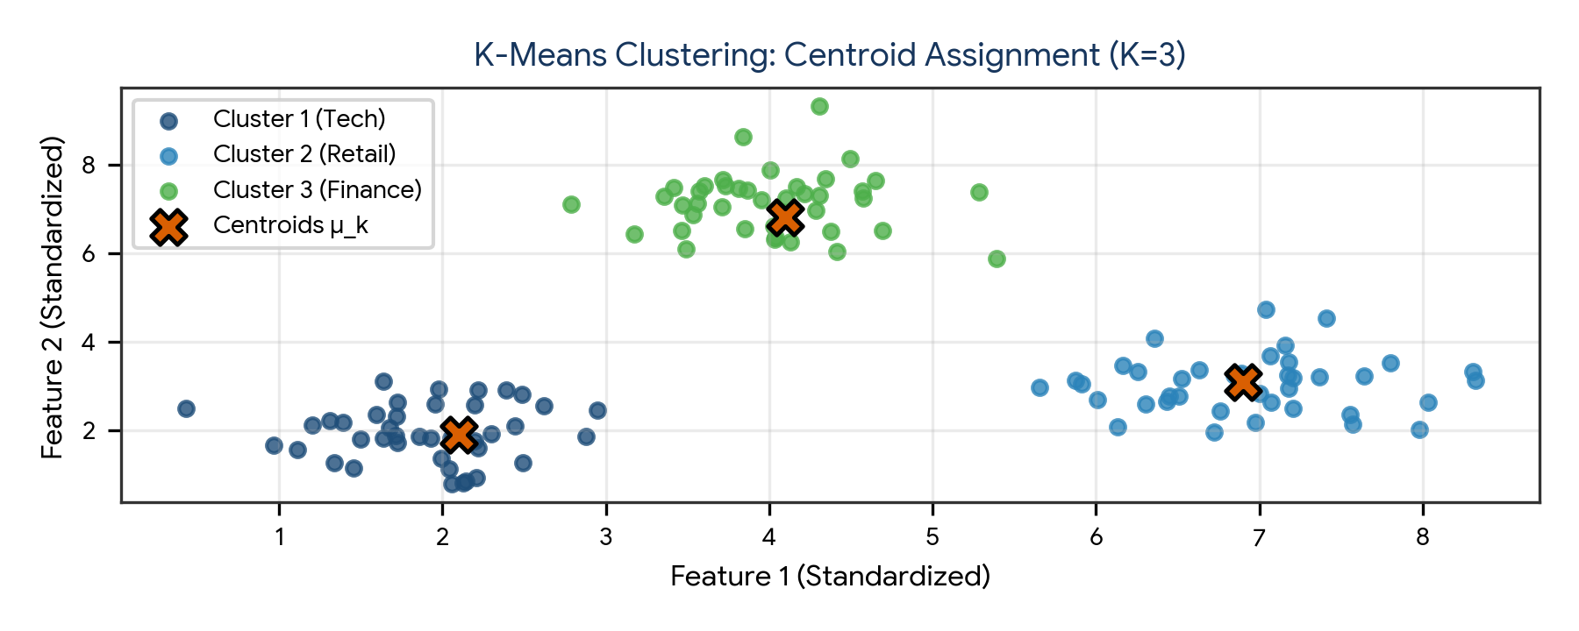
Figure 1. K-Means clustering assignment for K=3 showing data partition points and converged centroids (μ_k).
Algorithm Step | Mathematical Operation | Objective & Behavior
1. Initialization | Select K initial centroids {μ₁, μ₂, ..., μ_K} | Standard K-Means picks K random points; K-Means++ uses distance-weighted probability
2. Assignment Step | c_i = arg min_k ||x_i − μ_k||² | Assign each data point x_i to its nearest centroid based on squared Euclidean distance
3. Update Step | μ_k = (1 / |S_k|) Σ [x_i ∈ S_k] x_i | Recompute each centroid as the center of mass (mean vector) of all assigned observations
4. Convergence Check | ||μ_k^(t) − μ_k^(t-1)|| < ε or c_i^(t) = c_i^(t-1) | Repeat Steps 2 and 3 until centroids cease moving or maximum iterations are reached

The Objective Function (Inertia / WCSS)
K-Means minimizes the Within-Cluster Sum of Squares (WCSS), also referred to as Inertia:
WCSS / Inertia Formula:
J = Σ [k=1 to K] Σ [x_i ∈ S_k] ||x_i − μ_k||²

Where:
- K = Number of clusters
- S_k = Set of data points belonging to cluster k
- μ_k = Centroid of cluster k
- ||x_i − μ_k||² = Squared Euclidean distance from point x_i to centroid μ_k

Mathematical Note: K-Means optimizes WCSS via Coordinate Descent. It is guaranteed to converge,
but it converges to a LOCAL minimum rather than the global minimum. Running multiple restarts
with different initializations (n_init=10 in Scikit-Learn) mitigates sub-optimal local traps.

K-Means++: Smart Centroid Initialization
Standard random centroid initialization frequently causes K-Means to converge to poor local minima (e.g., placing two centroids inside the same natural cluster). In 2007, Arthur and Vassilvitskii introduced K-Means++:
- Step 1: Choose the first centroid μ₁ uniformly at random from the dataset.
- Step 2: For every remaining data point x, compute D(x), the distance to the closest already-chosen centroid.
- Step 3: Choose the next centroid μ_k with probability proportional to D(x)²: P(x) = D(x)² / Σ D(x')².
- Step 4: Repeat Steps 2 and 3 until all K centroids are chosen, then run standard K-Means.

3. Distance Concepts & Similarity Metrics
Clustering algorithms depend fundamentally on distance metrics to quantify dissimilarity between feature vectors. The choice of distance metric defines the geometric topology of the clusters.
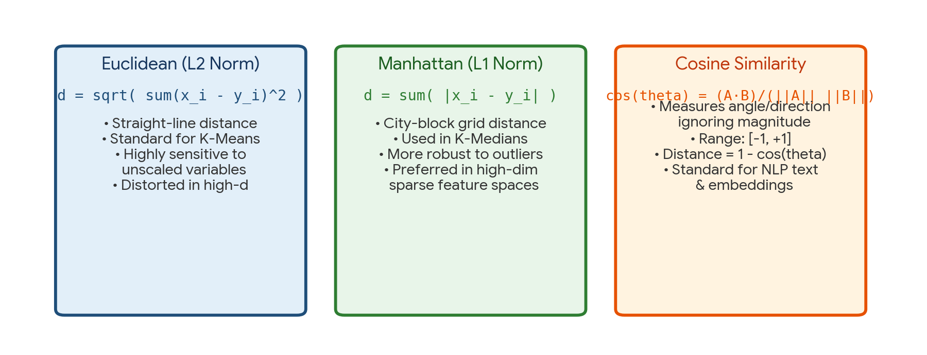
Figure 2. Comparison of core distance metrics: Euclidean (L2), Manhattan (L1), and Cosine Similarity.
Distance Metric | Mathematical Formulation | Geometric Meaning | When to Use & Caveats
Euclidean Distance (L2 Norm) | d(x, y) = sqrt( Σ (x_i − y_i)² ) | Shortest straight-line distance in Euclidean space | Default for K-Means; highly sensitive to unscaled features; suffers in high dimensions (curse of dimensionality)
Manhattan Distance (L1 / City Block) | d(x, y) = Σ |x_i − y_i| | Grid-based distance traveling along orthogonal axes | Used in K-Medians clustering; more robust to outliers than Euclidean; effective for sparse/grid features
Minkowski Distance (L_p Norm) | d(x, y) = [ Σ |x_i − y_i|^p ]^(1/p) | Generalized distance metric (p=1 is Manhattan; p=2 is Euclidean) | Hyperparameter tuning in KNN; flexible p-norm parameterization
Cosine Similarity | cos(θ) = (x · y) / (||x|| ||y||) | Cosine of the angle between two non-zero vectors; range [−1, +1] | Standard for NLP text documents, TF-IDF vectors, and high-dimensional sparse embeddings (measures direction, ignores magnitude)
Cosine Distance | d_cos(x, y) = 1 − cos(θ) | Angular dissimilarity metric; bounded in [0, 2] | Clustering text documents or recommendation systems where document length varies widely

The Curse of Dimensionality in Distance Calculations
As feature dimensionality d increases, the volume of the space grows exponentially, and all pairwise Euclidean distances converge to roughly the same value: lim [d→∞] (d_max − d_min) / d_min → 0. In high-dimensional spaces (d > 50), Euclidean distance loses its discriminative power, making dimensionality reduction (e.g., PCA) mandatory before clustering.

4. Choosing Optimal K: Elbow Method & Silhouette Analysis
Because K-Means requires the programmer to specify K a priori, evaluating clustering quality without ground truth labels is critical. Two complementary methods are standard in data science.
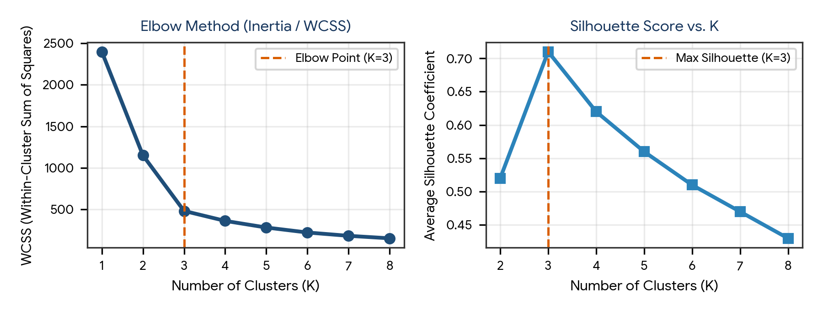
Figure 3. Determining optimal K using the Elbow Method (left, elbow at K=3) and Silhouette Analysis (right, peak score at K=3).
Validation Method | Evaluation Metric | Optimal Selection Rule | Pros & Limitations
Elbow Method | Within-Cluster Sum of Squares (Inertia / WCSS) | Look for the sharp 'elbow' bend where rate of WCSS decline drastically diminishes | Computationally fast; intuitive; however, the elbow is often ambiguous or smooth in real noisy data
Silhouette Analysis | Silhouette Coefficient s(i) ∈ [−1, +1] | Select K that maximizes the average Silhouette Score across all samples | Quantifies both cohesion and separation; provides per-sample diagnostics; computationally slower O(n²)
Davies-Bouldin Index | R_ij = (s_i + s_j) / d(μ_i, μ_j); DB = (1/K) Σ max R_ij | Lower is better (minimum DB index) | Evaluates ratio of within-cluster scatter to separation distance; fast to compute
Calinski-Harabasz Index | Variance Ratio: (Between-cluster var / Within-cluster var) | Higher is better (maximum CH index) | Ratio of between-cluster dispersion to within-cluster dispersion; very fast for large datasets

Detailed Mathematical Anatomy of the Silhouette Coefficient
For an individual observation i belonging to cluster A:
Silhouette Coefficient Formula:
s(i) = [ b(i) − a(i) ] / max( a(i), b(i) )

Where:
- a(i) = Mean intra-cluster distance: average distance from point i to all other points in its own cluster A.
(Measures cohesion: smaller a(i) means tighter cluster).
- b(i) = Mean nearest-cluster distance: average distance from point i to all points in the closest neighboring cluster B.
(Measures separation: larger b(i) means well-separated cluster).

Interpretation of s(i):
- s(i) ≈ +1.0: Point i is extremely well clustered; far away from neighboring clusters (b >> a).
- s(i) ≈ 0.0: Point i lies directly on the decision boundary between two clusters (b ≈ a).
- s(i) < 0.0: Point i is misclassified; it is closer to points in a neighboring cluster than its own (a > b).

5. The Complete Clustering Engineering Workflow
A production-ready clustering pipeline follows a disciplined 6-stage lifecycle, with special emphasis on feature scaling and post-clustering business profiling.
Production Clustering Pipeline Architecture:

Raw Unlabeled Tabular Data (X)
|
v
1. Data Preprocessing & Outlier Treatment:
- Median Imputation for missing values
- Outlier capping (IQR / Isolation Forest) - K-Means centroids are highly sensitive to extreme outliers
|
v
2. Feature Standardization (MANDATORY):
- Apply StandardScaler() -> z = (x - μ) / σ
- Without scaling, large-variance features completely dominate distance computations!
|
v
3. Dimensionality Reduction (Optional for d > 10):
- Apply PCA to compress collinear features, denoise, and mitigate curse of dimensionality
|
v
4. Hyperparameter Search (Finding K):
- Iterate K from 2 to 10
- Plot Elbow Curve (Inertia) & Silhouette Scores
|
v
5. Fit Final K-Means++ Model:
- Fit model using optimal K with n_init=10 (to avoid local minima)
- Assign cluster labels: df['Cluster'] = kmeans.labels_
|
v
6. Cluster Profiling & Business Actionability:
- Compute mean / median feature profiles per cluster: df.groupby('Cluster').mean()
- Assign human-interpretable personas (e.g., 'High-Value VIPs', 'Budget Churn Risks')

6. Dimensionality Reduction & Principal Component Analysis (PCA)
Principal Component Analysis (PCA) is an unsupervised, linear, orthogonal feature extraction technique that projects high-dimensional data onto a lower-dimensional subspace while preserving the maximum possible variance.
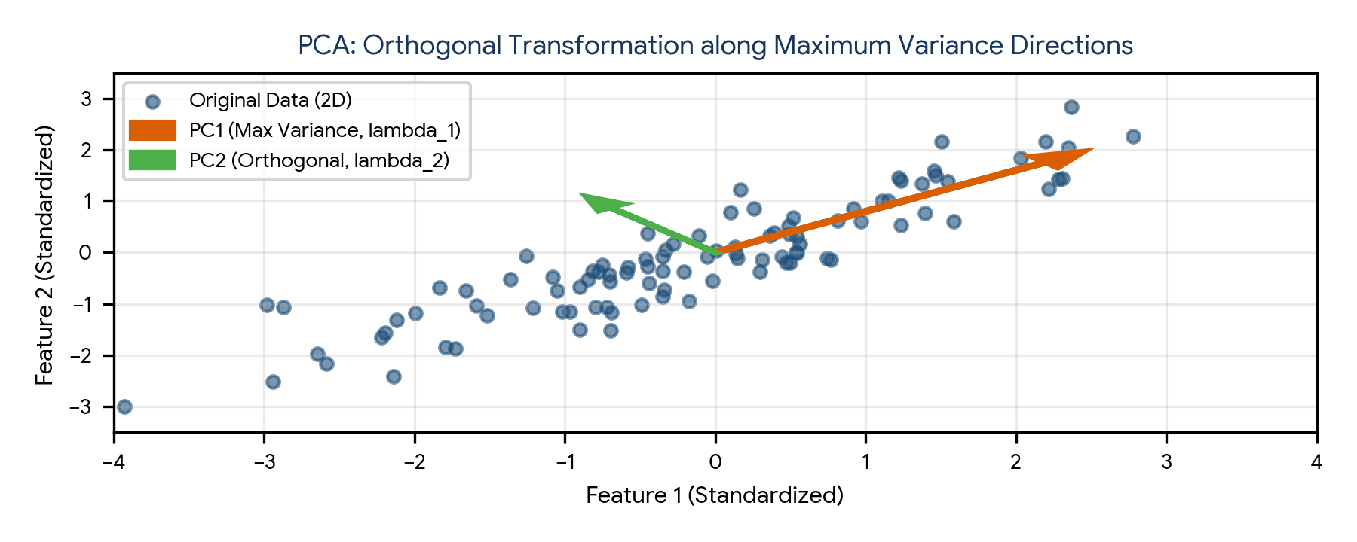
Figure 4. Orthogonal coordinate rotation in PCA: PC1 captures maximum variance direction; PC2 is strictly orthogonal capturing remaining variance.
Concept | Mathematical Formulation | Role & Physical Meaning
1. Feature Centering | X_std = (X − μ) / σ | PCA requires zero-centered data; otherwise PC1 simply points toward the data mean
2. Covariance Matrix | Σ = (1 / (n − 1)) X_std^T X_std | Captures pairwise linear associations and variance across all d features
3. Eigen-Decomposition | Σ v_j = λ_j v_j | v_j are eigenvectors (directions of principal axes); λ_j are eigenvalues (variance along that axis)
4. Orthogonality | v_i^T v_j = 0 for all i ≠ j | Guarantees that all principal components are completely uncorrelated (zero multicollinearity)
5. Projection Matrix | Z = X_std W_k | Projects original (n × d) data onto top k eigenvectors, yielding a compact (n × k) representation

SVD (Singular Value Decomposition) vs. Covariance Eigen-Decomposition
In modern software libraries (including Scikit-Learn), PCA is implemented via Singular Value Decomposition (SVD) on the centered matrix X rather than explicitly constructing the covariance matrix Σ:
SVD Matrix Factorization:
X = U S V^T

Where:
- U: (n × n) Left singular vectors (eigenvectors of X X^T)
- S: (n × d) Diagonal matrix of singular values s_j (related to eigenvalues by λ_j = s_j² / (n − 1))
- V^T: (d × d) Right singular vectors (transposed principal component loading vectors)
- Projection: Z = X V_k = U_k S_k

Computational Advantage: SVD avoids explicitly computing X^T X, providing superior numerical
stability and avoiding precision loss from matrix squaring.

7. The Scree Plot & Explained Variance Ratio
The primary decision in PCA is selecting the number of components k to retain. The Explained Variance Ratio quantifies the proportion of total dataset variance accounted for by each individual component.
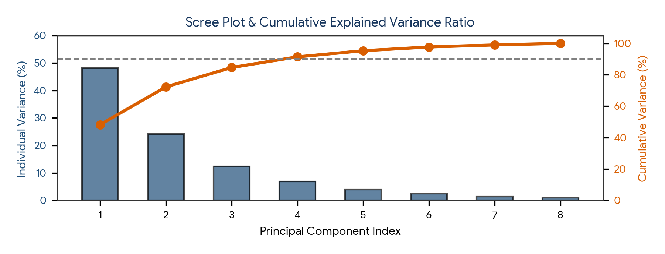
Figure 5. Scree plot: Individual variance explained per component (bars) and Cumulative explained variance curve (line).
Metric / Method | Formula / Rule | Decision Criteria
Individual Explained Variance | Ratio_j = λ_j / Σ [i=1 to d] λ_i | Percentage of total variance captured by principal component j alone
Cumulative Explained Variance | CumRatio_k = Σ [j=1 to k] λ_j / Σ [i=1 to d] λ_i | Common retention threshold: Retain minimum k components that explain 80% to 95% of total variance
Scree Plot Elbow Rule | Visual inspection of eigenvalue magnitude drop | Retain components prior to the leveling-off 'scree' plateau (Cattell's rule)
Kaiser Criterion | Retain components where eigenvalue λ_j > 1.0 | In standardized data (where each original feature had variance 1.0), only keep components that explain more variance than an individual feature

8. Practical Applications of Unsupervised Learning
Domain | Unsupervised Technique | Specific Industrial Application | Business Value Delivered
Retail & E-Commerce | K-Means on RFM (Recency, Frequency, Monetary) features | Customer segmentation into VIP, Loyal, At-Risk, and Churned cohorts | Personalized promotional campaigns, optimized ad spend, churn mitigation
Financial Services | PCA + Isolation Forest on transaction vectors | Unsupervised fraud detection and anti-money laundering (AML) | Flags zero-day fraud tactics without requiring historical fraud labels
Genomics & Healthcare | Hierarchical Clustering + PCA on gene expression data | Identifying novel cancer subtypes from tumor microarray profiles | Enables precision medicine, targeted therapies, and biomarker discovery
Image Processing & CV | PCA / SVD (Eigenfaces) & Vector Quantization | Face recognition baselines, image compression, and color quantization | Compresses image payloads by 80% while retaining structural facial contours
Cybersecurity | DBSCAN / K-Means on server access logs | Detecting coordinated Distributed Denial of Service (DDoS) attacks | Separates anomalous high-velocity IP traffic clusters from benign users

9. Practical Project — End-to-End Customer Segmentation & PCA Pipeline
Objective: design, implement, and benchmark an object-oriented Python pipeline that ingests continuous customer behavioral attributes (Annual Income, Spending Score, Age, Loyalty Score), standardizes features, executes PCA for dimensionality reduction and 2D projection, determines optimal K using the Elbow method and Silhouette Analysis, fits a K-Means++ model, and generates cluster profile summaries.

Project structure
customer_segmentation_project/
|
|-- data/
| |-- customer_data.csv
|
|-- reports/
| |-- cluster_profiles.csv
| |-- segmentation_analysis.png
|
|-- main.py
|-- requirements.txt

requirements.txt
numpy
pandas
scipy
scikit-learn
matplotlib
seaborn

Complete main.py
import os
import numpy as np
import pandas as pd
from sklearn.preprocessing import StandardScaler
from sklearn.decomposition import PCA
from sklearn.cluster import KMeans
from sklearn.metrics import silhouette_score
import matplotlib.pyplot as plt
import seaborn as sns

class CustomerSegmentationPipeline:
def __init__(self, n_samples=600, random_state=42):
self.n_samples = n_samples
self.random_state = random_state
self.output_dir = "reports"
os.makedirs(self.output_dir, exist_ok=True)
self.data = None
self.scaled_data = None
self.pca = None
self.pca_data = None
self.kmeans = None
self.optimal_k = 3

def generate_synthetic_customer_data(self):
print("=== STEP 1: INGESTING CUSTOMER BEHAVIORAL DATA ===")
np.random.seed(self.random_state)
n_per_cluster = self.n_samples // 3

# Cluster 1: Young Budget Shoppers (Low Income, High Spending)
c1_income = np.random.normal(30000, 6000, n_per_cluster).clip(15000, 45000)
c1_spend = np.random.normal(78, 8, n_per_cluster).clip(60, 100)
c1_age = np.random.normal(24, 4, n_per_cluster).clip(18, 35)
c1_loyalty = np.random.normal(2.5, 0.8, n_per_cluster).clip(1, 5)

# Cluster 2: Affluent High-Spenders (High Income, High Spending)
c2_income = np.random.normal(95000, 12000, n_per_cluster).clip(70000, 140000)
c2_spend = np.random.normal(82, 7, n_per_cluster).clip(65, 100)
c2_age = np.random.normal(38, 6, n_per_cluster).clip(25, 55)
c2_loyalty = np.random.normal(4.2, 0.5, n_per_cluster).clip(2, 5)

# Cluster 3: Conservative Savers (Moderate/High Income, Low Spending)
c3_income = np.random.normal(75000, 10000, n_per_cluster).clip(50000, 110000)
c3_spend = np.random.normal(25, 8, n_per_cluster).clip(5, 45)
c3_age = np.random.normal(52, 7, n_per_cluster).clip(35, 70)
c3_loyalty = np.random.normal(3.0, 0.9, n_per_cluster).clip(1, 5)

income = np.concatenate([c1_income, c2_income, c3_income])
spend = np.concatenate([c1_spend, c2_spend, c3_spend])
age = np.concatenate([c1_age, c2_age, c3_age])
loyalty = np.concatenate([c1_loyalty, c2_loyalty, c3_loyalty])

self.data = pd.DataFrame({
"Annual_Income": income.round(2),
"Spending_Score": spend.round(1),
"Age": age.round(0),
"Loyalty_Score": loyalty.round(1)
})
print(f"Generated {self.data.shape[0]} customer records across {self.data.shape[1]} features.")
print(self.data.head(3))

def preprocess_and_standardize(self):
print("\n=== STEP 2: MANDATORY FEATURE STANDARDIZATION ===")
scaler = StandardScaler()
self.scaled_data = scaler.fit_transform(self.data)
print("StandardScaler applied: mean = 0, standard deviation = 1 across all features.")

def optimize_cluster_count_k(self):
print("\n=== STEP 3: OPTIMIZING K VIA ELBOW & SILHOUETTE ANALYSIS ===")
k_range = range(2, 8)
wcss = []
silhouette_scores = []

for k in k_range:
km = KMeans(n_clusters=k, init="k-means++", n_init=10, random_state=self.random_state)
labels = km.fit_predict(self.scaled_data)
wcss.append(km.inertia_)
sil = silhouette_score(self.scaled_data, labels)
silhouette_scores.append(sil)
print(f"K={k} | WCSS (Inertia): {km.inertia_:.1f} | Silhouette Score: {sil:.4f}")

# Best K is maximum silhouette score
best_idx = np.argmax(silhouette_scores)
self.optimal_k = list(k_range)[best_idx]
print(f"Optimal K selected: {self.optimal_k} (Max Silhouette = {silhouette_scores[best_idx]:.4f})")

def execute_pca_and_kmeans(self):
print(f"\n=== STEP 4: PCA DECOMPOSITION & K-MEANS FITTING (K={self.optimal_k}) ===")
self.pca = PCA(n_components=2, random_state=self.random_state)
self.pca_data = self.pca.fit_transform(self.scaled_data)

var_ratio = self.pca.explained_variance_ratio_
print(f"PCA Variance Explained: PC1 = {var_ratio[0]*100:.2f}%, PC2 = {var_ratio[1]*100:.2f}% (Total = {sum(var_ratio)*100:.2f}%)")

self.kmeans = KMeans(n_clusters=self.optimal_k, init="k-means++", n_init=10, random_state=self.random_state)
self.data["Cluster"] = self.kmeans.fit_predict(self.scaled_data)
self.data["PC1"] = self.pca_data[:, 0]
self.data["PC2"] = self.pca_data[:, 1]

def profile_and_visualize_clusters(self):
print("\n=== STEP 5: CLUSTER PROFILING & REPORT EXPORT ===")
profiles = self.data.groupby("Cluster")[["Annual_Income", "Spending_Score", "Age", "Loyalty_Score"]].mean()
profiles["Customer_Count"] = self.data["Cluster"].value_counts()
print(profiles.round(2))

profiles.round(2).to_csv(os.path.join(self.output_dir, "cluster_profiles.csv"))
print(f"Cluster profile CSV saved to: {self.output_dir}/cluster_profiles.csv")

# Visualization
fig, ax = plt.subplots(figsize=(8, 5))
scatter = ax.scatter(
self.data["PC1"], self.data["PC2"],
c=self.data["Cluster"], cmap="Set2", s=30, alpha=0.8, edgecolor='k', lw=0.5
)
ax.set_title("Customer Segmentation in 2D PCA Space", fontsize=11, fontweight='bold', pad=10)
ax.set_xlabel(f"PC1 ({self.pca.explained_variance_ratio_[0]*100:.1f}% Variance)")
ax.set_ylabel(f"PC2 ({self.pca.explained_variance_ratio_[1]*100:.1f}% Variance)")
plt.colorbar(scatter, ax=ax, label="Cluster Label")
plt.tight_layout()
plt.savefig(os.path.join(self.output_dir, "segmentation_analysis.png"), dpi=300)
plt.close()
print(f"Segmentation plot saved to: {self.output_dir}/segmentation_analysis.png")

def run(self):
self.generate_synthetic_customer_data()
self.preprocess_and_standardize()
self.optimize_cluster_count_k()
self.execute_pca_and_kmeans()
self.profile_and_visualize_clusters()
print("\nComplete unsupervised learning pipeline executed successfully.")

if __name__ == "__main__":
pipeline = CustomerSegmentationPipeline()
pipeline.run()

Run the project
pip install -r requirements.txt
python main.py

Expected generated outputs
reports/
|-- cluster_profiles.csv
|-- segmentation_analysis.png

Project notes: standardizing features ensures that Annual Income (in tens of thousands) does not dwarf Spending Score (in tens). Reducing to 2 Principal Components allows direct visual inspection while retaining the dominant variance of the dataset.

10. Common Mistakes & Anti-Patterns to Avoid in Unsupervised Learning
- Clustering without feature scaling: Forgetting to standardize features causes attributes with large numeric scales to completely hijack distance metrics and cluster assignments.
- Using K-Means on non-spherical or arbitrary density shapes: K-Means assumes spherical, equally sized clusters. It fails on concentric circles, moons, or elongated density bands (use DBSCAN instead).
- Treating Inertia as an absolute quality metric: Inertia strictly monotonically decreases toward zero as K approaches n. An Inertia of 0 occurs when K = n, which provides zero clustering value.
- Applying PCA on raw uncentered data: PCA eigenvectors require zero-centered data (mean = 0); failing to center causes PC1 to reflect the data mean vector rather than the axis of maximum variance.
- Ignoring the Out-of-Sample / Test Leakage in PCA: Fitting PCA on both training and test sets leaks test covariance structures. Fit PCA strictly on the training set, then call pca.transform() on test data.
- Treating PCA components as original features: Principal components are linear combinations of all input features; interpretability of individual original features is lost unless examining factor loadings.
- Assuming PCA removes non-linear dependencies: PCA only decorrelates linear relationships (Cov(PC_i, PC_j) = 0). Non-linear dependencies between features remain intact.

11. Quick Revision — Key Differences
Comparison | First Concept | Second Concept
Supervised vs Unsupervised | Learns from explicit labeled pairs (X, y); optimizes empirical prediction error | Learns from unlabeled features (X only); discovers innate structure and patterns
K-Means vs K-Means++ | Picks K initial centroids purely at random; prone to poor local minima | Picks initial centroids using D(x)² distance weighting; ensures faster, superior convergence
Elbow Method vs Silhouette Analysis | Heuristic visual bend in WCSS curve; often ambiguous on noisy data | Rigorous metric s(i) ∈ [−1, +1] measuring both cluster cohesion and separation
Euclidean vs Manhattan Distance | Straight-line L2 distance; sensitive to outliers and high dimensions | Orthogonal grid-based L1 distance; robust to outliers; better for sparse data
PCA vs Feature Selection | Feature Extraction: creates new orthogonal features by combining all inputs | Feature Selection: discards uninformative features while retaining original subsets
K-Means vs DBSCAN | Centroid-based; requires specifying K; forces all points into spherical clusters | Density-based; discovers arbitrary shapes and automatically isolates noise/outliers

12. Important Formulas Cheat Sheet
Concept / Metric | Mathematical Formula / Notation
Within-Cluster Sum of Squares (WCSS / Inertia) | WCSS = Σ [k=1 to K] Σ [x_i ∈ S_k] ||x_i − μ_k||²
Euclidean Distance (L2 Norm) | d(x, y) = sqrt( Σ [j=1 to d] (x_j − y_j)² )
Manhattan Distance (L1 Norm) | d(x, y) = Σ [j=1 to d] |x_j − y_j|
Cosine Similarity | cos(θ) = (x · y) / (||x||₂ ||y||₂) = [ Σ x_j y_j ] / [ sqrt(Σ x_j²) sqrt(Σ y_j²) ]
Silhouette Coefficient s(i) | s(i) = [ b(i) − a(i) ] / max( a(i), b(i) ), where s(i) ∈ [−1, +1]
Sample Covariance Matrix | Σ = (1 / (n − 1)) X_std^T X_std
PCA Eigen-Decomposition | Σ v = λ v, where v is eigenvector and λ is eigenvalue
Explained Variance Ratio (PC_j) | Ratio_j = λ_j / Σ [i=1 to d] λ_i
Cumulative Explained Variance | CumRatio_k = Σ [j=1 to k] λ_j / Σ [i=1 to d] λ_i

13. Interview / Viva Questions
What is the fundamental objective of K-Means clustering?
To partition n observations into K clusters such that the Within-Cluster Sum of Squares (WCSS / Inertia)—the squared Euclidean distance between points and their assigned centroids—is minimized.
How does K-Means++ improve over standard K-Means?
Standard K-Means picks initial centroids randomly, often converging to poor local minima. K-Means++ chooses the first centroid randomly, then selects subsequent centroids with probability proportional to their squared distance from existing centroids, spreading them out.
Why is feature scaling mandatory before running K-Means?
K-Means uses Euclidean distance. If one feature has a scale of 10,000 to 100,000 (e.g., Salary) and another has a scale of 1 to 10 (e.g., Experience), the large feature will completely dominate distance calculations.
Explain the Elbow Method and its limitations.
The Elbow Method plots WCSS against K. The optimal K is chosen at the 'elbow' where the marginal decrease in WCSS slows down. Its limitation is that the elbow is frequently smooth and ambiguous in real-world data.
What is the Silhouette Score and what do its values signify?
The Silhouette Score measures how well-separated and cohesive clusters are: s = (b − a) / max(a, b). A score near +1 means tightly clustered and well-separated; near 0 means overlapping boundaries; negative values mean samples are in the wrong cluster.
What are the primary limitations of K-Means clustering?
1. Requires specifying K in advance; 2. Sensitive to outliers and initialization; 3. Assumes spherical clusters of equal size; 4. Fails on non-linear or arbitrary density geometries (e.g., moons, concentric circles).
When would you choose Manhattan distance over Euclidean distance?
When features are high-dimensional and sparse, or when the dataset contains significant outliers, because Manhattan (L1) penalizes extreme errors linearly rather than quadratically.
Why is Cosine Similarity preferred for text documents and embeddings?
Because it evaluates the angle between vectors rather than their Euclidean length, meaning a short article and a long article on the exact same topic will have high cosine similarity regardless of word count.
What is Principal Component Analysis (PCA)?
An unsupervised linear technique that transforms a set of correlated features into a smaller set of uncorrelated, orthogonal variables called Principal Components, ordered by the amount of variance they retain.
Why must data be centered before computing PCA?
Because PCA finds directions of maximum variance around the origin. If data is not zero-centered, the first principal component will point toward the mean of the data cloud rather than the axis of maximum spread.
What is the relationship between eigenvalues and explained variance in PCA?
Each eigenvalue λ_j equals the variance of the data along the corresponding eigenvector (principal component). Dividing λ_j by the sum of all eigenvalues yields the explained variance ratio.
What is a Scree Plot and how is it used?
A line plot of eigenvalues / explained variance ratio ordered from largest to smallest. It is used to identify the 'elbow' point where additional components contribute negligible variance.
What is the difference between PCA and Factor Analysis?
PCA is a mathematical transformation that summarizes total observed variance into orthogonal components. Factor Analysis is a statistical model that assumes observed variables reflect unobserved latent factors plus unique noise.
Can PCA be used for supervised feature selection?
No. PCA is an unsupervised feature extraction technique (it creates new linear combinations without looking at target labels y). A component with small variance might actually hold the strongest predictive signal for y.
How does PCA mitigate multicollinearity in linear models?
All principal components are orthogonal (v_i^T v_j = 0) and therefore perfectly uncorrelated. Replacing correlated raw features with PCs completely eliminates multicollinearity (VIF = 1.0).
What is the difference between K-Means and DBSCAN?
K-Means is centroid-based, partitions all data into K spherical clusters, and cannot detect noise. DBSCAN is density-based, discovers arbitrary shapes without specifying K, and automatically isolates noise as outliers.
What is the curse of dimensionality and how does it affect clustering?
In high dimensions, the volume of space expands so rapidly that all points become roughly equidistant from each other, rendering Euclidean distance distinctions meaningless.
What is Singular Value Decomposition (SVD) and why is it used in PCA?
SVD factorizes a matrix as X = U S V^T. Scikit-Learn uses SVD directly on centered data because it avoids explicitly calculating X^T X, which preserves numerical precision and prevents rounding errors.
How do you interpret the loadings in PCA?
Loadings are the weights (eigenvector coefficients) assigned to each original feature in forming a principal component. A large positive loading means that original feature contributes heavily to that component.
Can K-Means handle categorical variables directly?
No. K-Means calculates arithmetic means of coordinates, which is mathematically invalid on categorical labels. Use K-Modes for pure categorical data, or K-Prototypes for mixed data.

14. Coding Practice
- Implement standard K-Means clustering from scratch in pure Python and NumPy without using scikit-learn.
- Implement the K-Means++ smart initialization algorithm and verify that it requires fewer iterations to converge than random initialization.
- Write a Python script that computes Within-Cluster Sum of Squares (Inertia) and plots the Elbow Curve for K = 1 to 10.
- Implement a custom function that computes the Silhouette Coefficient for each sample and returns the average score without scikit-learn.
- Simulate non-spherical datasets (make_moons and make_circles) and compare clustering outputs between KMeans and DBSCAN.
- Demonstrate the effect of feature scaling on K-Means by clustering unscaled vs. StandardScaler-transformed customer records.
- Implement PCA from scratch using NumPy by calculating the sample covariance matrix, eigen-decomposition, and matrix projection.
- Verify that your scratch PCA implementation produces identical explained variance ratios to scikit-learn's PCA (via SVD).
- Plot a dual-axis Scree Plot displaying individual variance explained as a bar chart and cumulative variance as a line chart.
- Apply PCA to the 64-dimensional Digits dataset and plot the first two principal components color-coded by digit class.
- Build an end-to-end customer RFM (Recency, Frequency, Monetary) clustering pipeline that exports cluster personas to a CSV report.
- Demonstrate data leakage in PCA: show the difference between fitting PCA on the entire dataset vs. fitting strictly on the training partition.

15. Day 393 Completion Checklist
- ☐ Understand the fundamental concepts and objectives of Unsupervised Machine Learning.
- ☐ Master the iterative mechanics of K-Means (Assignment and Update steps).
- ☐ Explain how K-Means++ smart initialization avoids poor local minima.
- ☐ Understand Euclidean, Manhattan, Minkowski, and Cosine distance metrics.
- ☐ Explain the curse of dimensionality and why Euclidean distance degrades in high dimensions.
- ☐ Determine optimal K using both the Elbow Method (WCSS/Inertia) and Silhouette Analysis.
- ☐ Execute the complete 6-stage clustering engineering lifecycle with mandatory scaling.
- ☐ Formulate PCA through covariance eigen-decomposition and Singular Value Decomposition (SVD).
- ☐ Interpret Scree plots and select components using cumulative explained variance thresholds.
- ☐ Connect unsupervised algorithms to industrial applications (RFM segmentation, fraud detection, genomics).
- ☐ Build and run the practical Customer Segmentation & PCA Pipeline project.
- ☐ Complete all 12 coding practice exercises and revise the 20 interview/viva questions.

16. Learning Outcomes
After completing this revision, you should be able to:
- Formulate, configure, and evaluate centroid-based clustering models using K-Means and K-Means++.
- Select appropriate distance metrics based on feature dimensionality, sparsity, and domain characteristics.
- Rigorously identify optimal cluster counts using both WCSS elbow heuristics and silhouette diagnostics.
- Apply Principal Component Analysis (PCA) to compress high-dimensional feature spaces while preserving maximum variance.
- Eliminate multicollinearity and project complex multi-attribute datasets into interpretable 2D/3D visualizations.
- Translate mathematical cluster centroids into actionable, human-interpretable business segmentation personas.
Next recommended topic: Day 394 — Advanced Unsupervised & Model Selection: Hierarchical Clustering, DBSCAN, t-SNE, UMAP, Hyperparameter Tuning, and Pipeline Validation.

